Letting Go of the Long Gone

a free verse, sensual, emblem poem

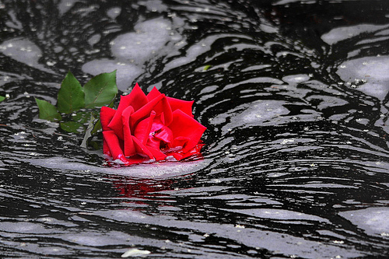

-created by rissystories

I wrap my arms
Around his neck and
Laugh as he carries me on his back.
He smiles, then sighs, as he has done many times before.
Sincerity is lacking, along with his will to walk out the door.
But it is necessary to sway him out of his secluded state,
Free him from the darkness residing within his room and head.
We are having fun under the setting sun, along the bend of a deep
River, but then he lowers me down onto the ground and frowns.
I should have known that this bliss was too good to be true.
This man is a withdrawn wallflower who only socializes in fantasy,
And he hates the notion of devotion to our troubled reality.
Somber, I silently oblige and walk with him side by side,
But I don’t dare dream of walking with him hand in hand,
Because God forbid he ever slid into one of my fantasies.
Holding hands, enjoying company, and love is what I desire,
His version of delusion is to drown in loneliness, and retire.
I sometimes ponder and wonder if he even loves me anymore.
Unfocused and unaware, my shoe suddenly slips on a rock,
And sends me tumbling into the violent and turbulent river.
The strong tide takes me, but my hand breaks the surface,
My heart flutters as his hand firmly grasps mine
Before I flounder and fly away with the tide.
But he is wrong to think that he is strong,
And splashes along beside me.
He sinks much faster than I can,
While still gripping my hand.
But I realize that this is reality,
And not just my fantasy,
For I am sinking too.
His weight pulls me
Farther under water
He holds my
Hand tight, but
This is not
My fantasy.
No. His
Clutch
Is
Out
Of
Fear, not love.
I cannot rise
And save both
Of our lives.
His burden would
Be our demise.
So, I knew
That I needed
To choose.
Drowning and flailing,
A fleeting look in his blue eyes catches mine,
But I see nothing, he’s gone, not there anymore.
I then realize something that I hadn’t before
And let go of his hand before I hit the river floor.
Numbness flows through my veins and my heart wilts like a flower.
The water swallows him whole, but I rise and ride the tide back to shore.
I lie flat on the rocks and watch the sun set on the river’s other side,
Knowing that our love was never truly meant to survive.

